Code

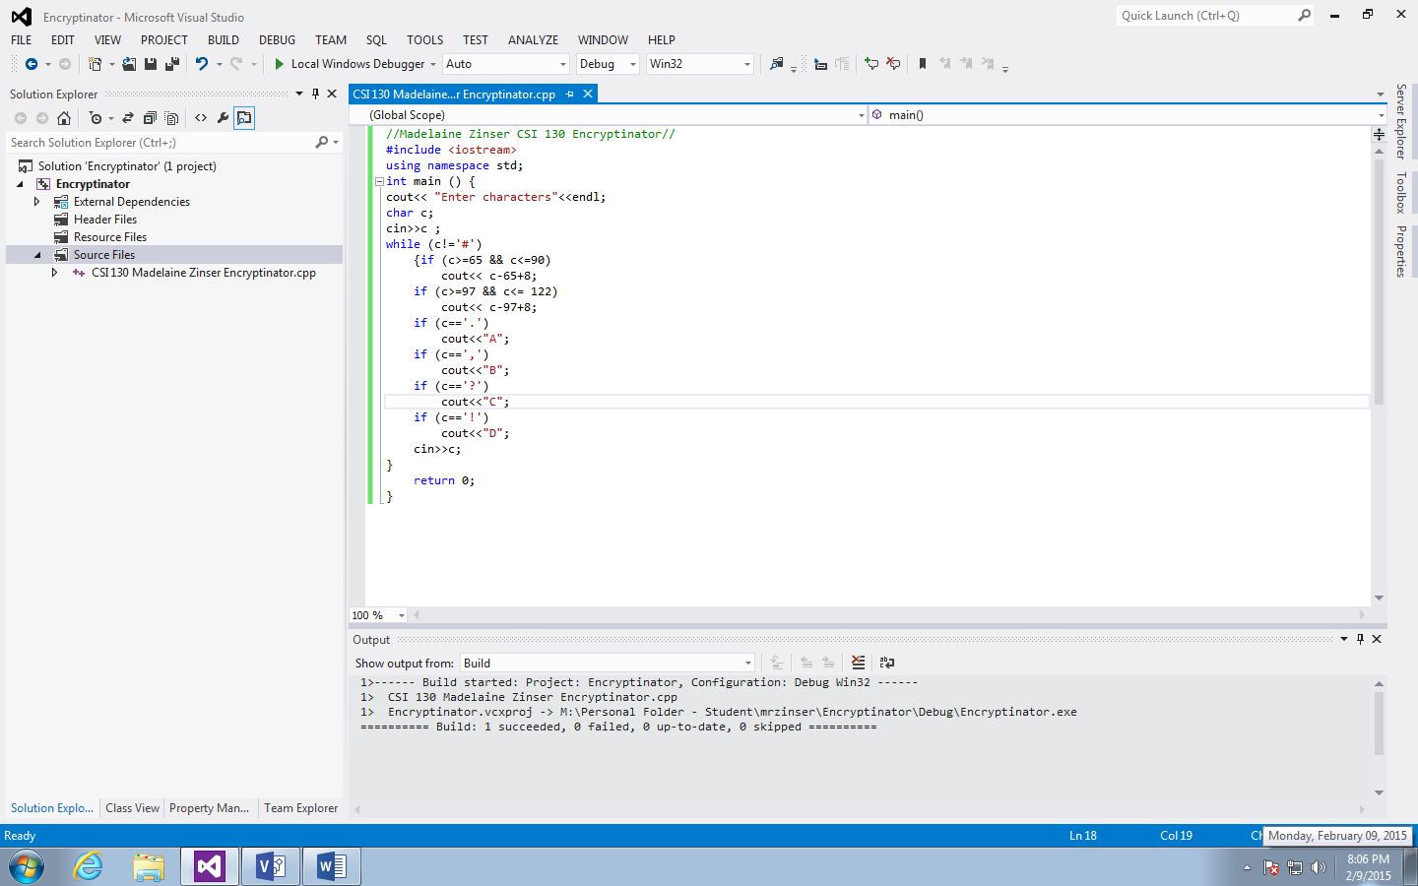

Code Tracing

|  |  |
| --- | --- |
| c | cout |
|  | AZ amzM dog is barking.,!+># |
| ~~A~~ | 8 |
| ~~Z~~ | 33 |
| ~~a~~ | 8 |
| ~~m~~ | 20 |
| ~~z~~ | 33 |
| ~~M~~ | 20 |
| ~~d~~ | 11 |
| ~~o~~ | 22 |
| ~~g~~ | 14 |
| ~~i~~ | 16 |
| ~~s~~ | 26 |
| ~~b~~ | 9 |
| ~~a~~ | 8 |
| ~~r~~ | 25 |
| ~~k~~ | 18 |
| ~~i~~ | 16 |
| ~~n~~ | 21 |
| ~~g~~ | 14 |
| ~~.~~ | A |
| ~~,~~ | B |
| ~~?~~ | C |
| ~~!~~ | D |
| ~~+~~ |  |
| ~~>~~ |  |
| ~~#~~ | *end* |